City University London
BSc (Hons) Computer Science
Final Year Project Report
Academic Year: 2013-14


A Web-based Booking System with Improvements for Hobbs Dry Cleaners & Launderette business
by
Gurvinder Kaur

Supervisor: Dr. Vladimir Stankovic
13th May 2014
Contents
Abstract 5
Forthcoming chapters 7
Introduction chapter 1 7
Output summary chapter 2 7
Literature review chapter 3 7
Methods chapter 4 7
Results chapter 5 7
Conclusions and discussions chapter 6 7
Glossary chapter 6 7
References chapter 7 7
1 Introduction chapter 8
1.1 Introduction 8
1.2 Background 8
1.3 Problem drivers 8
1.4 Problems to be solved 9
1.4.1 Business problems 9
1.4.2 System development 10
1.5 Project assumptions 10
Project scope 11
1.6 Outline of work 11
1.7 Project objectives 11
1.7.1 Primary objective 11
1.7.2 Aids achievement of objectives 12
1.8 Project beneficiaries 12
2 Outputs summary chapter 13
2.1 Introduction 13
2.2 Project definition 13
2.3 Requirement specification 13
2.4 Design specification 14
2.5 System testing 15
2.6 Working Hobbs web-based booking system 15
2.7 User-manual 15
2.8 User evaluation 16
3 Literature review chapter 16
3.1 Introduction 16
3.2 Similar functionality web-based booking system 17
3.3 Web-based systems 17
3.4 Java servlets and JSP 18
3.5 HTML 18
3.6 CSS 18
3.7 MySQL database 19
3.8 Eclipse software 19
3.9 Apache TomCat server 19
4 Method Chapter 20
4.1 Introduction 20
4.2 Web-based development life cycle 20
4.2.1 Iterative and incremental development (Agile method) 20
4.3 Project plan 20
4.4 Gathering requirements phase 21
4.4.1 Use-case modelling and specifications 21
4.4.2 Functional/ non-functional requirements 21
4.5 Gathering Design phase 22
4.5.1 Graphical user interface wire frame 22
4.5.2 Class diagram 22
4.5.3 Sequence diagram 23
4.5.4 Deployment diagram 23
4.5.5 Entity relationship diagram 23
4.6 Gathering Implementation phase 24
4.6.1 Setting up a working environment 24
4.6.2 Backups 24
4.6.3 Source code 24
4.6.4 Third party services 25
4.6.5 Testing Phase 25
4.6.6 Evaluation 25
5 Results chapter 25
5.1 Introduction 25
5.2 Informal discussion/ unstructured interview 26
5.3 Requirement Phase 26
5.4 System development/ architecture 26
5.5 Outputs analysis 26
5.6 Requirements 26
5.7 Design phase 26
5.8 Implementation phase 26
5.8.1 Specific algorithms and coding decisions 26
5.9 Testing phase 26
5.10 Verification and evaluation 27
6 Conclusions chapter 27
6.1 Introduction 28
7 Glossary chapter 28
8 References chapter 28
9 Appendices 28
9.1 Client emails/ Meeting minutes 28
9.2 Initial Use-Case Diagram 29
9.3 Revised Use-Case Diagram 29

Abstract
Note: Wherever the word ‘author’ is mentioned, this is referring to Miss Gurvinder Kaur.
Wherever the word ‘client’ is mentioned, this is referring to Mr Tika Lal Bomjan.
The aim of this project was to design and build an advanced and useful web-based booking system for ‘Mr Tika Lal Bomjan’ - the author’s client who is an employee at a dry cleaning and laundry business, well known as ‘Hobbs’ or ‘Hobbs of Reading’. It is also based for all customers to book their service order online via PayPal for secure payments, view service prices, contact the business and retrieve more knowledge about the business.
There are various webpages, main ones are the home, price-list, order and contact us. The employee ‘admin’; requires to log in and visit the admin panel to manually add, update and remove all the services which are displayed in the price list page, also can view order history. Order page is only accessible for two separate customer accounts created; only if the customer and commercial business customer are logged in.
This ‘Project Report Document’ focuses on guiding the reader through the web-based system developments; methods used, results, evaluation of the system and also explain the obstacles the author faced during the implementation phase. Hobbs’s previous system had difficulty with easily tracking customer information, order history and transactions because all records were written down by hand, this allowed there to be room for human error, and delay in referencing records with very little security.

Forthcoming chapters
The inclusive report chapters are briefly specified in the following:

Introduction chapter 1
This chapter explains the background, problem drivers, and problems to be solved, project objectives, scope, beneficiaries, summary of the work planned to meet the objectives.

Output summary chapter 2
This chapter provides a summary of the outputs produced from the project which the client will receive in the end. It will give an overview description of each deliverable, type of output produced, type of recipient or end-user and its use.

Literature review chapter 3
This chapter provides the initial research and reading undertaken to develop the end results. It also includes the related outputs stated above.

Methods chapter 4
This chapter analyses the methods that were used to design, build and then test the Hobbs’ web-based booking system.

Results chapter 5
This chapter outlines the results and follows all the development stages from the phases indicated in the Method section.

Conclusions and discussions chapter 6
This chapter allows the author to evaluate the project and draw conclusion in terms of what the author has learnt and what could have been done differently, and what could be improved on the system.

Glossary chapter 6
This chapter defines abbreviations and terminology descriptions which are unfamiliar to the readers.

References chapter 7
This chapter lists all the reference of related information or sources revised for the build, design and report.

Introduction chapter

Introduction
The following chapter is intended to introduce the reader to the client-based project and to provide an understanding of the problems that prompted to design and build the web-based system with an addition to the booking system, as well as the developments of the system. This will be broken down into segments consisting of the project background, problem drivers, problems to be solved, project objectives, project scope, project beneficiaries, summary of the work planned to meet the objectives and subsequent chapters within this report.

Background
Hobbs Dry Cleaners and Launderette is a local private business specialising in various services such as dry cleaning, laundry, ironing, alterations and repair. The indication of the project instigated throughout an informal conversation with the client ‘Tika Lal Bomjan’. The author was informed about the plans of Hobbs expanding their business by welcoming new commercial business customers to be contracted with their businesses with pick-up and delivery for all the services they provide. It is thus vital for Hobbs to ensure the internal and external performance of their business is of the highest standards.
The client usually felt pressurised by his daily tasks. Hobbs needed to make changes to their management procedures to allow them to easily trace service orders, customer details, enable customers to view their order states as pending or completed and payments to be securely received through an online system. The main problem was to avoid numerous handwritten records that were difficult to read and stressful to keep track of.
In order for Hobbs to smoothly run with their plans of expansion, it was important to have an organised system where everything would be securely stored and easily accessible, thus the idea of a web-based booking system integrated with admin functionality.

Problem drivers
In today’s technology we see various businesses continuously expanding which leads to more competition. For this reason, the author had been given a requirement from the client to create a web-based booking system in order to help make the business operate with ease and efficiency, and have an organised and productive way of handing day-to-day routine tasks. Hobbs’s previous system had difficulty dealing with customer records, payments, dates, and times of collection and delivery services, transactions because all records were written down by hand. This allowed room for human error, as well as delay in referencing records. Their main driver for this change is due to the lack of features in their website, and lack of efficiency in productivity in creating and securely storing records.

Problems to be solved

Business problems
At present, Hobbs is operating through face-to-face interaction with customers, telephone and managing hand written paper records. This can become a problem when the number of customers increases, as known Hobbs is expanding their business and welcoming new commercial contracts. The client faces several issues with their daily management with their tasks, for instance confusion with business customers for their collection and delivery dates and times, difficulty with tracking payments as at times papers get misplaced or lost. This also proves to be time-consuming when certain information is needed directly, as well as a major security issue.
Therefore the business requires improvements in the way it functions and would like to be operated in an organised way to manage records easily and efficiently via a web-based system. Business and come-in customers would be satisfied as the client who is the admin of the system can add the information that needs to be displayed on the web page. In this case, the admin can edit and delete services manually without having to go into the technical or programming procedure to view or search any information they require about the service, including a contact page for any more questions. Also with this web-based system, it improves day-to-day routine tasks including being able to manage service orders, collection and deliveries, and to be able to track payments with the order histories.
The business and come-in customers have separate log-in accounts as only business customers are only provided with the collection and delivery option for their service ordered by the business at present. PayPal takes the following payments for both customers securely. The come-in customer can drop and collect their service with ease, without any hassle of paying right there or waiting to be served as they have made their payment online. Commercial business customers do not need to travel to the laundry as they can easily make their service orders and select their collection and delivery preferences online, which can be done from their work place or home.
This system would overall make the business’s management very efficient; it would be clearer and organised for the client. It wouldn’t take time to trace paper records and retrieve secure payments. Therefore more time can be saved on providing excellence in the services provided to both types of customers, their usage experience and successful management of the entire business.

System development
In terms of development, the author faced problems with mapping Servlets to JSPs because it was the author’s first time using this technology. Also PayPal integration was a challenge as the author had to do further research to learn how to connect the order page services to PayPal, and to allow admin to view both customers’ order history back on the Hobbs Web-based System from PayPal’s cart page.
In terms of testing environment, the author faced problems with the online environment. Since the author was developing the web-based system, there was no domain to run the system on for testing. The web-based system did not perform the same way as it would on a real web domain. In order to overcome this problem, the author used an Apache Tomcat Server. This enabled the web system to perform as if it was running on a real web domain. The Apache Tomcat Server was useful for the author in order to run tests before the product handover was done to the client.

Project assumptions
It is assumed that the project compromises of more programming in four different languages; JSP, HTML, CSS and MySQL. The remaining less is devoted to UML design specification, requirements and testing.
The final web-based system is to be viewed on PC or laptop using all browsers but the author has used Apache Tomcat Server to emulate a real web-based site. The author has used the following web browsers; Google Chrome, Firefox and Internet Explorer to see the results ensuring the design and functionality are working effectively on these browsers. The author has used Google Chrome to test the functionality throughout the development of the web-based system. Once it’s hosted it will run directly from the World Wide Web. Hobbs’s current web site URL will be replaced with the new developed web-based system’s URL.

Project scope
In the past Hobbs has lost many contracts with commercial businesses due to the unorganised procedure of managing service orders, human errors and problems with storing and re-accessing the paper records. The scope of this project was to design and build a web-based booking system with improvements to their existing website. This system should discourse all the specific issues and fulfil the client’s requirements without compromising any features and not exceeding the deadline of the project.

Outline of work
To achieve the design and functionality of the web-based system working, several tasks were undertaken. To begin with, the author needed to research into the business, client’s requirements and analyse what was required to be done. Using the requirements elicited from the client through various meetings, the basis of the web-based system was designed and developed. The system was coded with JSP and Servlets, HTML, CSS and MySQL Database. The author has done extra reading on how to use JSP and servlets for the implementation. The web-based system was tested to check for errors and evaluated against the initial objectives, and requirements.
For reference of the outline of the work produced please refer to Appendix [Initial Work Plan] of this report where you will find an initial work plan followed for the project when considering the requirements, outputs, timelines, delays which are all valid considerations. There were changes made in the work plan due to the difficulties faced with implementation therefore you can find a revised version of the work plan in Appendix [Revised Work Plan]. This was required to ensure all project requirements were effectively met on time.

Project objectives
The complexity of the initial requirements discussion meetings and project definition stages meant that objectives were constantly being added or refined to meet requirements discussed in regular meetings with the client.

Primary objective
The main objective of the project was to be met:
The main objective for this project was to deliver an improved web-based system that includes accurate and secure bookings for service washes, dry cleaning and ironing requests. Also provide precise information about the business and confirms services to be completed in a professional manner. All decisions were agreed between the client and author with meeting minutes signed, you can find this in Appendix [Client Meeting Minutes] For security purposes, the form of payment was decided through PayPal as it allows support for all different types of cards, and it more safe and secure to use.
To meet the requirements of the main objective, the following sub-objectives were to be met:
- To document software development, the sub-objectives are broken into the following stages:
- Requirement specification to capture key requirements that would include the non-functional and functional requirements.
- Design specification to get an outlook of the design of the system.
- Testing specification to attain results through system testing ensuring all of the client’s requirements are met. The author must produce test cases and determine if they pass or fail. The author will also allow customers within the dry cleaning and laundry business to test Hobbs’ system and fill in the answers through a questionnaire for feedback to ensure it satisfies their needs before delivering the project to the client.
- User manual that would act as a means of user training for the client to teach new members of staff coming into the business so they are aware of how to use the newly developed web-based system effectively.
- To generate and deliver a fully functional web-based system during the implementation phase which completely meets the client’s requirements.

Aids achievement of objectives
Literature review to be carried out throughout the requirements, design and implementation phases on the technologies that can be used to implement the web-based system and to get an insight on similar existing systems.

Project beneficiaries
The following beneficiaries have been identified from the project’s planned results:
- The client, Mr Bomjan will benefit from this project because with this web-based system, his business will be able to keep track of transactions and customer details in a secure way, which can be easily traced by an authenticated user if old records need to be looked at. This leads to good organisation especially when a number of customers increase, time-management for when certain information is required instantly and ease of use with this tracking method. It also minimises human error, as their current system is all handwritten, paper-based records that are unsecure and can easily fall into the wrong hands. The project will give the client a fully functional website to enhance their business relations with their customers.
- The business customers will also benefit from this web-based system. This is because they can make service requests from the comfort of their home/office instead of having to come into the laundry store, or telephoning the business. What the system also does is keeps a record of a customer’s requests, so they can always log back in to check their request history. As well as that, they are now able to make a secure card transaction via widely used PayPal. By using PayPal, the system will not have to deal with credit card details and worrying about keeping them safe, and not storing them anywhere as PayPal will take care of all of that on their end.
- The author will be a beneficiary because this project will enable her to indulge in new technologies. The author will be able to gain a lot of new knowledge and experience from this project as well as develop on her time management, software development, client relations and self-management skills. Most importantly the author will pass this work as part of her individual project, which is required for her to graduate.

Outputs summary chapter Introduction chapter

Introduction
In the outputs summary chapter, the author will illustrate and give references of all the outputs required to complete the report.

Requirement specification
Output type: | System’s Requirements Specification Document
Overview description: | This consists of the criteria the system must meet including information about the business and user requirements. In which there will be the functional and non-functional requirements, use-case specifications conceptions from the use-case modelling. This specification defines the use-cases in detail gathered from the client.
Purpose: | The author uses the system requirement specification to start creating the Design Specification of the system. This includes all the use-case modelling depicting users undertaking behaviours associated with the intended system, and explaining the operations or interactions provided for the users with the system.
Recipient/ end User: | Author, Supervisor, Client
Reference: | Appendix [Functional & Non-Functional Requirements] Appendix [Use-Case Specifications]

Design specification
Output type: | System’s Design Specification Document
Overview description: | This consists of all the UML diagrams the author designed using the Requirement Specification. It includes use-case diagram, class diagram, sequence diagram, and GUI framework of the web-based system. An architecture design was created of how the system works through a deployment diagram. A database design to generate the entity relationship diagram. All of these designs were revised after regular meetings with the client to ensure they met the client’s requirements before starting implementation. When there were changes made with client’s approval, design specifications were updated, referenced in appendix.
Purpose: | The author is updated with the design of the system by visiting the design specification. The client will be able to recognise how the system’s features and functionalities will be displayed ensuring it is meeting the requirements set.
Recipient/ end User: | Author, Supervisor, Client
Reference: | Appendix [Use-Case Diagrams], Appendix [Class Diagram], Appendix [Sequence Diagram], Appendix [GUI Wireframe Designs], Appendix [Deployment Diagram] and Appendix [Entity Relationship Diagram]

System testing
Output type: | System Testing Document
Overview description: | The testing section ensured all the requirements have been captured correctly. While the system is implemented, the author had to do regular testing to not miss anything out and ensure it is functioning as it is supposed to.
Purpose: | The manual testing document helped the supervisor, client and staffs identify errors that were present within the system and procedures to solve this problem. It helped assess the success of the system and if the requirements of implementation were met.
Recipient/ end User: | Author, Supervisor, Client
Reference: | Appendix [Manual Testing]

Working Hobbs web-based booking system
Output type: | Working Web-based Booking System
Overview description: | This web-based includes an improved and fully functional booking system for Hobbs Dry Cleaners & Launderette as per requirements of client. The contents of the output will include all the programming language code using JSP and Servlets, HTML and CSS, the scripts and database scheme structure. The entire implementation source code is all referenced in appendix.
Purpose: | This web-based system needs to be working to accomplish the client’s requirements as well as allow the business to use this website by deploying the system and the database on the client’s server. This will enable the beneficiary usage of the web-based booking system.
Recipient/ end User: | Author, Supervisor, Client, Staff
Reference: | Appendix [Source Code]

User-manual
Output Type: | Hobbs Admin’s Training Manual Document
Overview Description: | The training manual document will help provide step-by-step instructions for a new Admin user on how to use the various functionalities on the new system.
Purpose: | This will enable the new Admin user to undertake training using the Hobbs Admin’s Training Manual Document to use the new web-based booking system for Hobbs Business effectively. The new user(s) will be able to learn on their own through this training manual so it avoids dependency on client (Manager). Also the client doesn’t need to worry about explaining everything repeatedly as all the operations will be explained clearly in this training manual document.
Recipient/ end User: | Supervisor, Client, Staff
Reference: | Appendix [Administrator User Manual]

User evaluation
Output Type: | User Evaluation Questionnaires
Overview Description: | The user evaluation provides questionnaires for the customers in Hobbs Dry Cleaners & Launderette to find out what their thoughts/ opinions are of the new system produced.
Purpose: | The user evaluation questionnaire enabled the author to receive feedback on the system from the commercial and come-in customers. The client and author was enabled to analyse these questionnaires to see where improvements were required.
Recipient/ end User: | Author, Client, Business Customers
Reference: | Appendix [Commercial Business Customer Questionnaire], Appendix [Customer Questionnaire]

Literature review chapter

Introduction
This purpose of literature review chapter is to provide an overview of the reading and analysis conducted by the author in order to accomplish the client’s requirements of the project. This consists of the research and reading undertaken to understand the suitable tools and technologies that needed to be used for the implementation and any particular methodologies adjusted. It also shows the research carried out into existing web-based systems with similar functionalities.

Similar functionality web-based booking system
The author studied on similar system as Hobbs’ system to allow a better understanding of what is available on the market and to generate ideas from what was discussed with the client for the development of Hobbs Web-based Booking System.
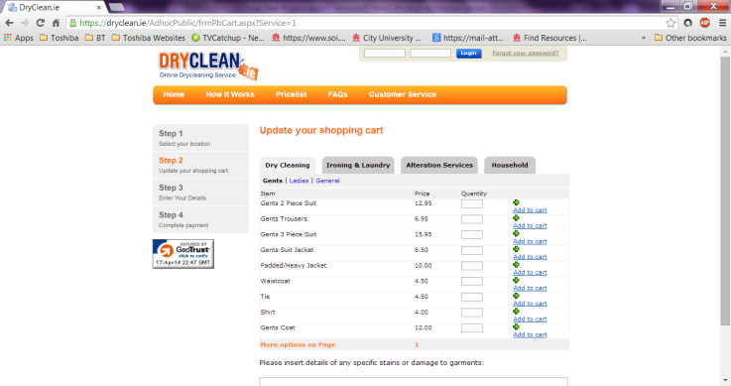
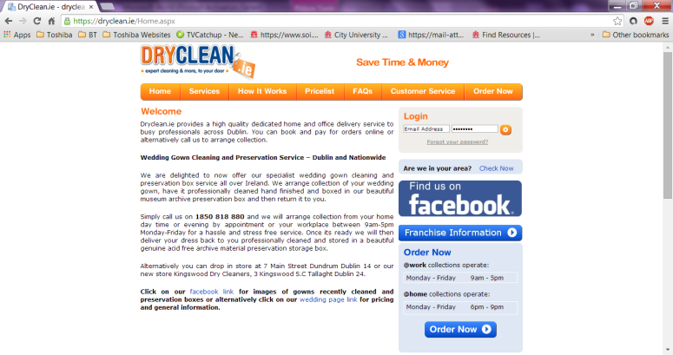
This website (on the right) has similar functionalities to the web-based booking system the author has developed. Although this website doesn’t provide an option to select collection and delivery details whereas the system developed for Hobbs has this functionality. Also admin or staff cannot log into system to edit or delete service inputs manually, also there is no image displayed of the service. Hobbs web-based system retrieves information from the MySQL database from where the admin/ staff inputs data; this displays the service name, description, price and image. Also Hobbs’ system is more secure as their payments are securely made via PayPal whereas this website does not have these options available. It is similar with the functionalities of a booking a service where the customer selects a dry cleaning or laundry service, is able to add it to the cart in order to make payment. The difference in Hobbs’ system is that not all services orders are collected and delivered therefore two separate logins are created for ‘commercial’ and ‘come-in’ customers.

Web-based systems
A web-based system is accessed through an internet connection or network. Most web-based systems are far more compatible across platforms than installed software. A web-based system only needs to be installed on the server placing minimal requirements on the end user workstation. User’s minimum requirement would be a web browser of which there are many such as Internet Explorer, Google Chrome, and Firefox etc. There web browsers are available for multitude operating systems and so whether you use Windows, Linux or Mac OS you can still run the web system. This allows maintaining and updating the system much simpler; it can be deployed via the web server with relative ease.
Web-based systems have obvious advantage that the end user does not require any major system requirements such as hardware, disk space and other computing properties.

Java servlets and JSP
JSP ‘Java Server Pages’ uses Java programming language; it is a technology that helps developers create dynamically generated web pages based on HTML code or other document types. A JSP is translated into Java servlet before being run and it processes HTTP requests and generates a response like any servlet. Conversely, JSP technology provides a more convenient way to code a servlet. A JSP translator is triggered by the .jsp file name extension in a URL. To deploy and run JSP, a compatible web server with a servlet container is required such as Apache Tomcat (which was used to view the site like on a real web domain). Referenced: http://en.wikipedia.org/wiki/JavaServer_Pages , http://www.webopedia.com/TERM/J/JSP.html

HTML
HTML ‘Hyper Text Mark-up Language’ is a set of mark-up tags that describe document content. HTML documents also known web pages contain HTML tags and plain text. The purpose of any web browser such as Firefox, Internet Explorer, Google, Safari, is to read HTML documents and display them as web pages. The browser does not display the HTML tags but uses the tag to determine how the content of the HTML page is to be displayed to the user. Referenced: http://www.w3schools.com/html/html_intro.asp

CSS
CSS ‘Cascading Style Sheets’ is a style sheet language used for describing the look and formatting of a document written in a mark-up language. It gives both website developers and users more control and insight over how pages are displayed. It is mostly often used to style website pages and interfaces written in HTM and XHTML, the language can be applied to any kind of XML document, including XML, SVG and XUL. These define how different how different elements, such as headers and links appear.
CSS is a cornerstone specification of the web and almost all web pages use CSS style sheets to describe their presentation. These CSS (style sheets) can be applied to any Web page. The term cascading derives from the fact that multiple style sheets can be applied to the same Web Page. CSS was developed by W3C. Referenced: http://en.wikipedia.org/wiki/ascading_Style_Sheets , http://www.webopedia.com/TERM/C/CSS.html

MySQL database
MySQL ‘Structured Query Language’ is the world’s most popular and open-source relational database, enabling the cost-effective delivery or reliable, high-performance and scalable web-based and embedded database systems. It allows great flexibility and expansion with other technologies such as Eclipse and JSP for a well-suited and appropriate solution. The data in MySQL is stored in tables. A table is a collection of related data, and it consists of columns and rows. It is useful for Hobbs business to store information categorically on the web-based system. Referenced: http://www.oracle.com/us/products/mysql/overview/index.html, http://en.wikipedia.org/wiki/My_SQL

Eclipse software
Eclipse software is a Java-based open source platform allowing developers to create a customized integrated development environment (IDE) from plug-in components built by Eclipse members. It is mostly written in Java; a major advantage with Eclipse is that it allows you to mix and match development tools rather than being committed to a single vendor’s suite of development products. B using various plug-ins, eclipse can also be used to develop and test code written in other programming languages such as Ada, C++, COBOL, Fortran, Haskell, JavaScript, PHP, Perl, Python, Ruby, R, Scala, Clojure, Scheme, Groovy, Scheme and Erlang. Referenced: http://en.wikipedia.org/wiki/Eclipse_software

Apache TomCat server
Apache Tomcat is an open source web server and servlet container developed by the Apache Software Foundation (ASF). Tomcat implements the Java Servlet and the Java Server Pages (JSP) specification from Sun Microsystems, and provides a “pure Java” HTTP web server environment for Java code to run in. In the simplest configuration, Apache Tomcat runs in a single operation system process. It has added user as well as web-based systems enhancement to add support for deployment across the variety of environment. It also tries to manage session as well as systems or applications across the network. Referenced: http://en.wikipedia.org/wiki/Apache_Tomcat

Method Chapter

Introduction
This methods chapter will outline all the techniques, external tools and methodologies that have been applied by the author for the contribution to the success of implementing and developing the overall project.

Web-based development life cycle

Iterative and incremental development (Agile method)
The author used an iterative and incremental methodology for this project. This was so the project could be divided into incremental portions, allowing each iterative to be reviewed with the client. Regular review sessions between the author and client were vital in order to ensure the client was fully aware and happy with project progress.
The iterative and incremental development approach allowed flexibility in terms of changes in the requirements. As each iterative cycle is independent of others, functionality within each iterative cycle can be tweaked.
Has the testing been done iteratively? You need to state the details.
This working methodology also encouraged more testing for the user, the testing has been done interactively. This is basically agile testing; it is an ongoing process and the tests are done in parallel to development. Therefore all iterations had been tested individually, and in conjunction with other iterations. Iterative usability testing is vital because the ultimate goal of all usability is to improve usability, not to increase problems.

Project plan
In order to make sure the project progressed at a steady pace and to have an estimation of effort required, the author made use of a Gantt chart highlighting moderately low-level tasks need to be complete for this project. In requirement to creating a Gantt chart, this was referred to the work plan which was created. The work plan is completed with estimated dates in the Gantt chart, along with allocated contingency time as something to fall back upon if required. The plan allows allocated time to train and practise, as it was the first time the author has indulged in such technologies. There were stages where tasks weren’t completed on time due to facing difficulty with implementation therefore a revised work plan was created for this solution. Please see Appendix [Initial Work Plan], Appendix [Revised Work Plan].

Gathering requirements phase

Informal discussion/ unstructured interview
The system requirements were initialised through an informal conversation between the author and the client. A rough idea of the features the system should have was discussed in person during an informal discussion. Please see Appendix [Informal Conversation/ Unstructured Interview]. This was later documented when the author responded with a list of requirements based on the previous conversation in regards to instigating this project. The requirements list was thoroughly discussed again with the client via regular meetings and emails to ensure both parties were in synchronisation with the project objectives and aim. Please refer to Appendix [Client Emails].

Use-case modelling and specifications
Once the project had been made official, the author exploited UML tools in the requirement phase by creating a use-case diagram consisting of actors linking to use-cases to provide a high level overview of the system. This represented the key behaviours and functions that the system would encapsulate as well as which user (actors) concerned from a type perspective were interacting with this specific behaviour. The actions made available to each user of the system are clearly outlined through a use-case diagram; please see Appendix [Initial Use-Case Diagrams]. The use-case modelling was reviewed with the client for further improvements in initial developments for consistency and accuracy. Please see final revised use-case diagram in Appendix [Revised Use-Case Diagrams].
In order to provide details on each use-case, the author then wrote use-case specifications against the use-case diagrams with brief description, detailing further pre-conditions of the behaviour to be undertaken, main flow where users undertake behaviours, post conditions as results from main flow and alternative flows after reaching the behaviour. This would enable the reader to have a more detailed view of the use-case attributes and how it is operated, please see Appendix [Use-Case Specifications].

Functional and non-functional requirements
The successful developments of use-case diagrams and specification enabled the user to derive key functional and non-functional requirements from the specified behaviours and functions through use-case modelling and understanding of the requirements captured from specifications. Please refer to Appendix [Functional and Non-functional Requirements].This enabled the author to abide upon the many features of the web-based system, namely the GUI framework, additional security, usability and training manuals

Client Meeting Minutes
These requirements were regularly reviewed in meetings, via telephone and emails with the client to verify, and to make revisions where appropriate. The confirmation to the requirement agreements made by client and author through meeting minute signed documents, please see this in Appendix [Client Meeting Minutes] and Appendix [Client Emails]. This clears out further clarifications made with the client regarding the requirements, including some additional work and changes made. The functional requirements were sought out to be feasible and valuable.

Gathering Design phase
The design phase includes all the outputs produced from output section and it is the next part after the requirement phase.

Graphical user interface wire frame
Once the functional requirements were visually displayed by means of a use-case diagram, the author decided it was time to start the design phase by drafting the face of the system. The author created Wireframe designs for the GUI ‘Graphical User Interface’, please refer to Appendix [GUI Electronic Wireframe Designs]. This allowed the client to have an idea of what the system would look like. This process was revisited a few times on paper and electronically as the client regularly changed his mind with the paper design as the author enhanced the website’s appearance to satisfy the client. Please see Appendix [GUI Paper Wireframe Designs].

Class diagram
Before implementation could start, in the design phase the author modelled the first cut assembly of the system using a class diagram in order to plan and visualise how the system should be structured, please refer to Appendix [Class Diagram]. Class diagram helps to see which classes would be present and how they would interact with each other. This class diagram was improved to provide detail of the structure in greater depth.
The main features that were introduced included multiplicity, attributes and operations, attribute types, operation return types and parameters, and extra new operations. New entity, control and boundary classes were also included depicting the communication between the existing classes. The class diagram was shown to the client however the client found it difficult to understand the complexity of the design and work out the message visually of what it was conveying because of the client’s lack of knowledge in UML. The author explained the structure in detail to the client in a clear and understandable manner. The client provided his views with feedback on the class diagram design. The class diagram was missing the new functionalities that were added into the web-based system such as collection and delivery details (date and time) input from customers and including the admin functionalities to view this information. The author made notes of these amendments and worked on adding the functionality. The class diagram was revised due to discussions in meetings, ensuring the diagram met the client’s requirements.

Sequence diagram
In design phase, the author modelled the interaction between objects in runtime, with the sequence of method invocation using a sequence diagram; please refer to Appendix [Sequence Diagram]. The class diagram and sequence diagram are related in this process with each other. The sequence diagram represented the sequence of actions that take place to carry out a certain task in the system, messages that were delivered and received, and classes are viewable in this diagram in order of occurrence.

Deployment diagram
In the design phase, a deployment diagram was created to visualize the topology of the physical components (hardware), their distribution and association with the web-based system where the software components are deployed. Please refer to this diagram in Appendix [Deployment Diagram]. The author ensured it consisted of nodes, and their relationships, also describing the static deployment view of the system. The deployment diagram represents how the client server would open a browser that requires Internet to show the JSP Servlets on the Apache Tomcat v7.0 Web Server via a JSBC connection to the MySQL database.

Entity relationship diagram
An ER ‘Entity Relationship' Diagram was formed from the MySQL Server database in order to describe the data of the process requirements in an abstract way that lend itself to eventually being implemented in the relational database scheme. The ER diagram provides a high-level visual appearance of the various tables within the entities in the database and their relationships that exist among them, please refer to Appendix [Entity Relationship Diagram]. The author ensured the ER diagram represented primary and foreign keys of tables as well as the cardinalities of relationship between tables. The client understood the ER diagram by the author showing its relation with the database scheme in the system.

Gathering Implementation phase
This phase described the web-based system’s development process according to the approaches put forward from the requirement and design phase.

Setting up a working environment
The author decided to use Eclipse EE with Apache Tomcat Server in conjunction with MySQL database. The author hadn’t used this combination before, but after doing some research found this to be the most popular and supported combination. There were several guides online available showing the configuration needed to connect the technologies together. Eclipse is where the main core of the development takes place; it runs an Apache Tomcat Server that hosts the web-system as if it were hosted on a domain. The database is also connected through a plugin available for Eclipse, allowing the author to easily create and maintain the database and its tables.

Backups
Due to the incremental and iterative development approach taken by the author, by its nature the development methodology encouraged the author to make numerous backups. However the author still put extra effort in making sure regular backups were made and stored in multiple locations. A daily backup would take place regardless of progress, as well as backups throughout the working time, after each change has been made. The backups were stored on the authors workstation, external hard drive, as well as on the cloud via Dropbox – by having Dropbox installed on multiple machines, it enabled multiple backups on other machines too. With each backup entry, marked in a special folder with the date and time, the author would also insert an entry in a change log with the same date and time. By utilising this technique, the author was able to track individual changes as well as have multiple backups of the project.

Source code
You need to explain the source code you developed.
Do not list all of the source code in the main body of the report (but you need to include it as Appendix certainly).
But provide pieces of the source code YOU developed and explain what they mean, giving references to other pices contained in the Appendix.

Third party services
The author used a third party API within the Hobbs Dry Cleaners and Launderette web-based system, by integrating external service with the application. A Google Map API was added and designed to be placed into the website’s Contact page. Please see more information on how to use this API Google Map on the Contact page in Appendix [Google Map API]

Testing Phase
The testing phase helped the author examine the developed Hobbs booking web-based system to ensure there are no faults and errors. Also demonstrated whether the requirements had been met or not. There were two different testing phases done; manual testing and user accepting testing. Manual testing was performed by the author throughout the development of the system and user acceptance testing system was performed by the client, refer to Appendix [Manual Testing]. The client allowed the author to ask customers within the business to test the developed system and fill in a questionnaire to attain feedback for improvements. Performance tests of the web-based system were also included; please refer to Appendix [Web-based System Performance Tests]

Evaluation
The evaluation represents the final stages of the project. The first part was having an informal discussion and making notes of all the present business problems. The second part was having regular meetings with the client to gain feedback whilst developing, making an action and then allowing client to review until completion with client signing it off to ensure the requirements is met. Third part was providing a feedback questionnaire to the come-in and business customers to attain their views on the website design and functionality, to make last improvements.

Results chapter

Introduction
The results chapter illustrates all the results acquired through project progress from initialisation to end including requirements, design, implementation and testing phases. This chapter also aims to describe the results of the various outputs and methods of the project.

System requirement acquisition and output analysis
The requirements phase included all the results from the above stated methods to capture the key tasks to ensure all the requirements of the overall project were met successfully.

Informal discussion/ unstructured interview
In order to have a better understanding and fully capture key requirements the author had an informal discussion with the client. The author made notes of all the issues the client had within managing the business. These results allowed the author to understand the functionalities required for the system as well as aims and objectives best suited for the project. Some of the key problems affecting the business include:
1. Difficult to track service orders by telephone
2. Stressfully tracing handwritten customer records and transactions
2. Losing customers with inefficient management of accounts
3. Time consuming searching for paper-records
4. Human errors with tracing references
5. Late collection and deliveries to customers
Please refer to Appendix [Information Discussion/ Unstructured Interview] for the entire list of problems affecting the business.

Functional and non-functional requirements
The author developed functional and non-functional requirements based through the analysis of the use-case modelling, specifications, key points noted from the informal discussion with client. Please refer to Appendix [Functional and Non-Functional Requirement] illustrates the functional and non-functional requirements agreed between author and client, and signed.

Use-Case Specification
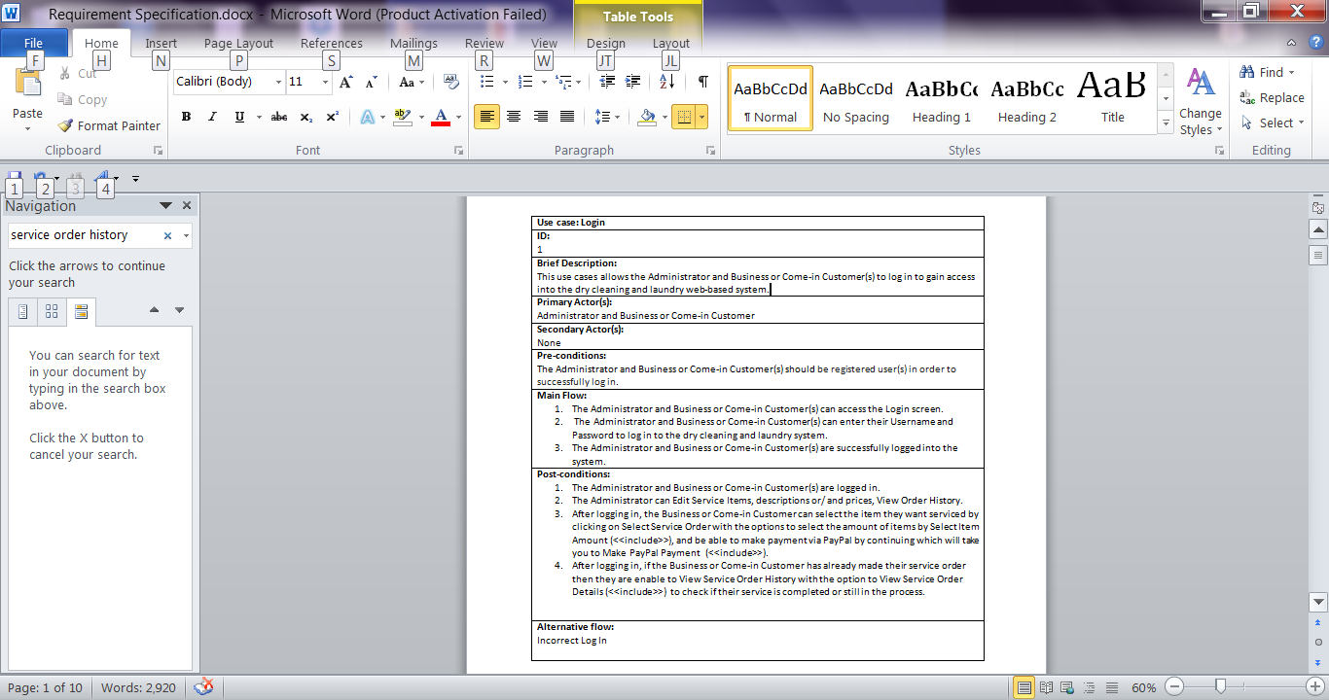
The author wrote out use-case specifications for all the individual use-cases created in the use-case diagram. It details a brief description, primary and secondary actors, pre-conditions, main flow, post-conditions and any alternative flows of the use-case. This enabled the client and author to understand how the admin or external actors such as the customers for example would interact with the system. The use-case specification is very useful when creating all the UML designs during the requirement and design phase. Figure 5.2.3.1 specifies an example of one of the use-case specification the author created for the use-case Log in. The entire collection of use-case specifications created by the author can be found in Appendix [Use-Case Specifications]. The author did not need to make so many separate changes to the use-case specification as it followed up the latest changes made to the use-case diagram. It provides a proved, detailed understanding of each use-case, especially if it is hard to visualise the requirements looking at the UML diagrams.
Figure 5.2.3.1: Use-Case Specification

System design analysis

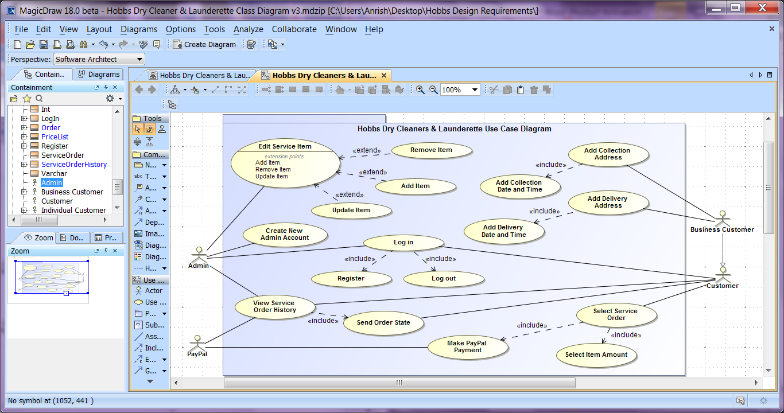
Use-Case Diagram
Figure 5.3.1.1: Revised: Use-Diagram
As part of the requirement phase, feedback was received from the client to improve the use-case diagram. This use-case model was created to portray the key actor’s interaction with the intended system to undertake behaviour associations for the web-based development.
Figure 5.3.1.1 use-case model shown graphically represents the key actors; Admin, Business Customer and Customer. Business Customer is generalised to Customer; both of these actors can book a service order by selecting their service, its item amount and make secure payments. The Business Customer is only provided with collection and delivery option, including the dates and times to do this. Admin can view service order histories, edit services and create staff account. Client confirmed by email that staff didn’t require to be generalised to Admin as all staff are known as admin and have the same privileges. All actors can log into the system or register to create an account. To see Figure 5.3.1.1 enlarged, it can be reviewed in part of the design phase in Appendix [Revised Use-Case Diagram], also the initial model can also be reviewed in Appendix [Initial Use-Case Diagram].

GUI wireframe designs and workflow specification
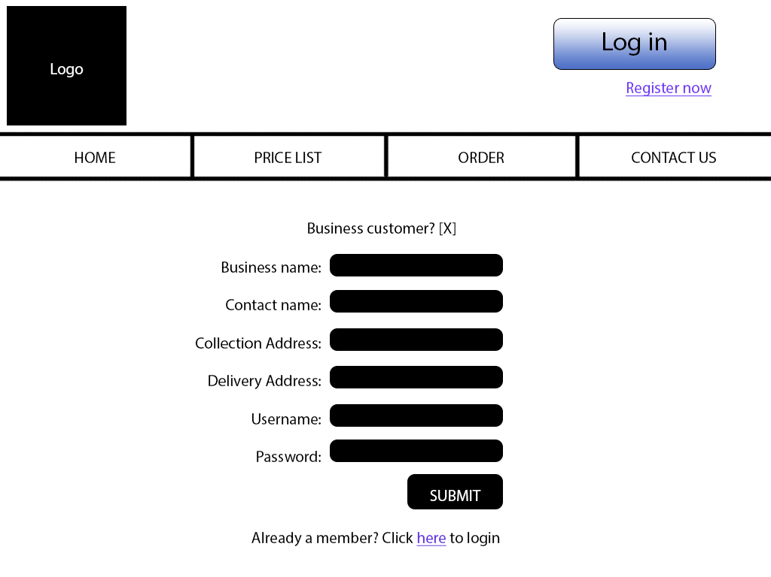
Knowing that the website is being made for a laundry business, the author thought the website layout should display a clean and clear GUI so customers are attracted with the same viewpoint of thinking about clean clothes washing services they provide etc. The user interface was built using a minimalist design, with a white and grey colour scheme. The main navigation buttons are located on the top right corner of the header with the Log in displayed on every page and all webpages are consistently designed throughout. Figure 5.3.2.1 GUI wireframes were designed as a start-up visualisation of how the website should look; the complete results of the GUI wireframe designs with its description are included in the Appendix [GUI wireframe designs and workflow specification].
Figure: 5.3.2.1 GUI Wireframe Design

Class diagram
The author formed a class diagram upon creation of the use-case modelling and specifications; the class diagram demonstrates the associations between all of the classes within the web-based system. This helped the author to visualise how the application will fit together. This diagram includes all the classes that are linked to the implementation within the system in the requirement and design phase. Figure 5.3.3.1 shows a class diagram created by the author. Please refer to Appendix [Class Diagram] for an enlarged version.

Sequence diagram
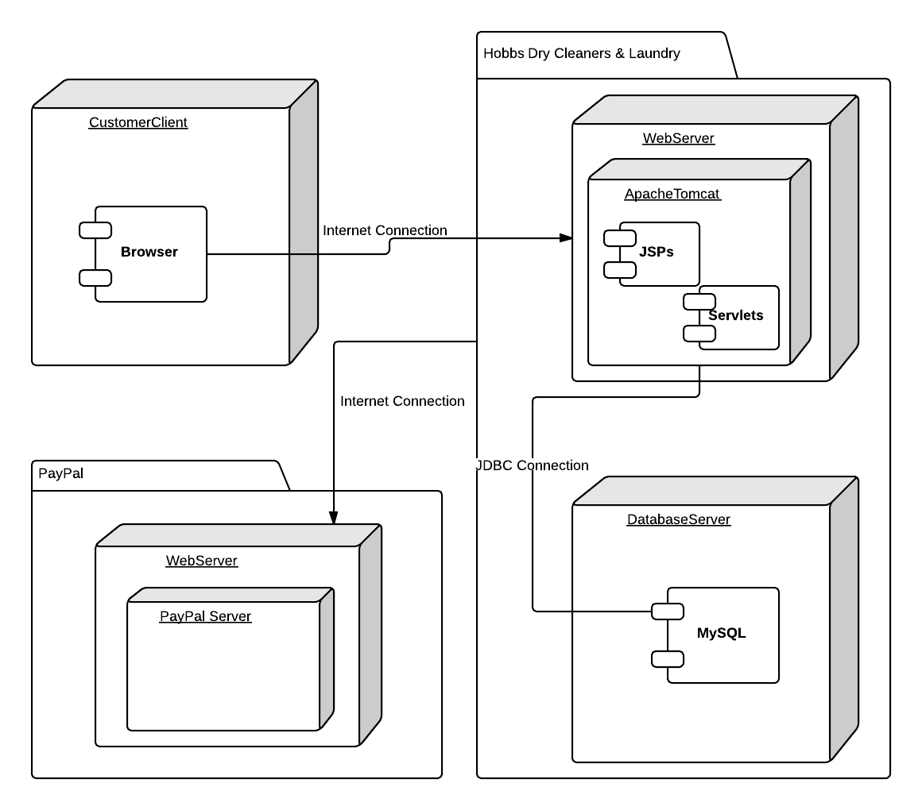
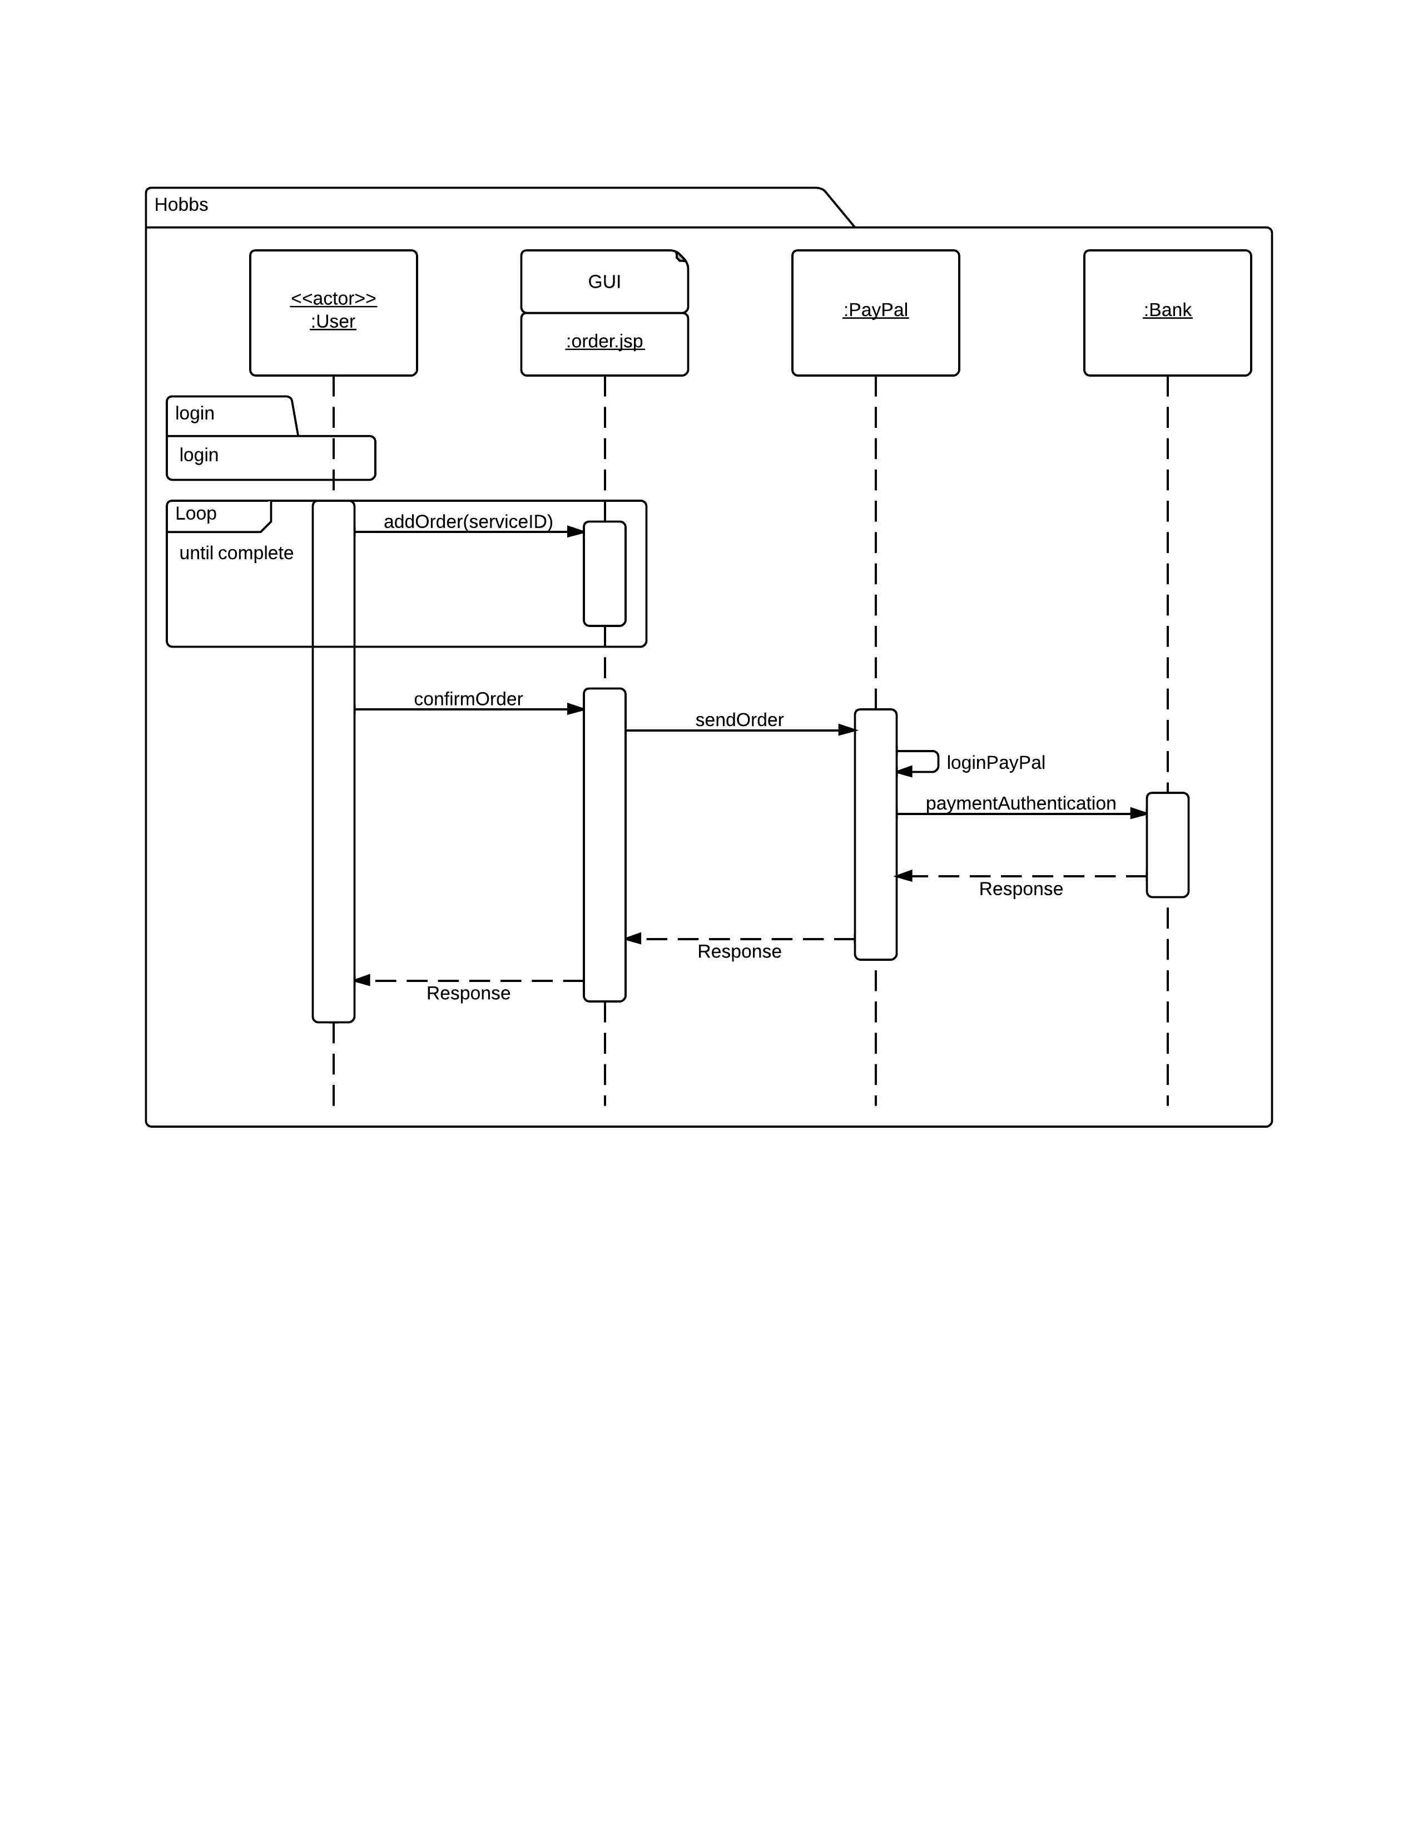
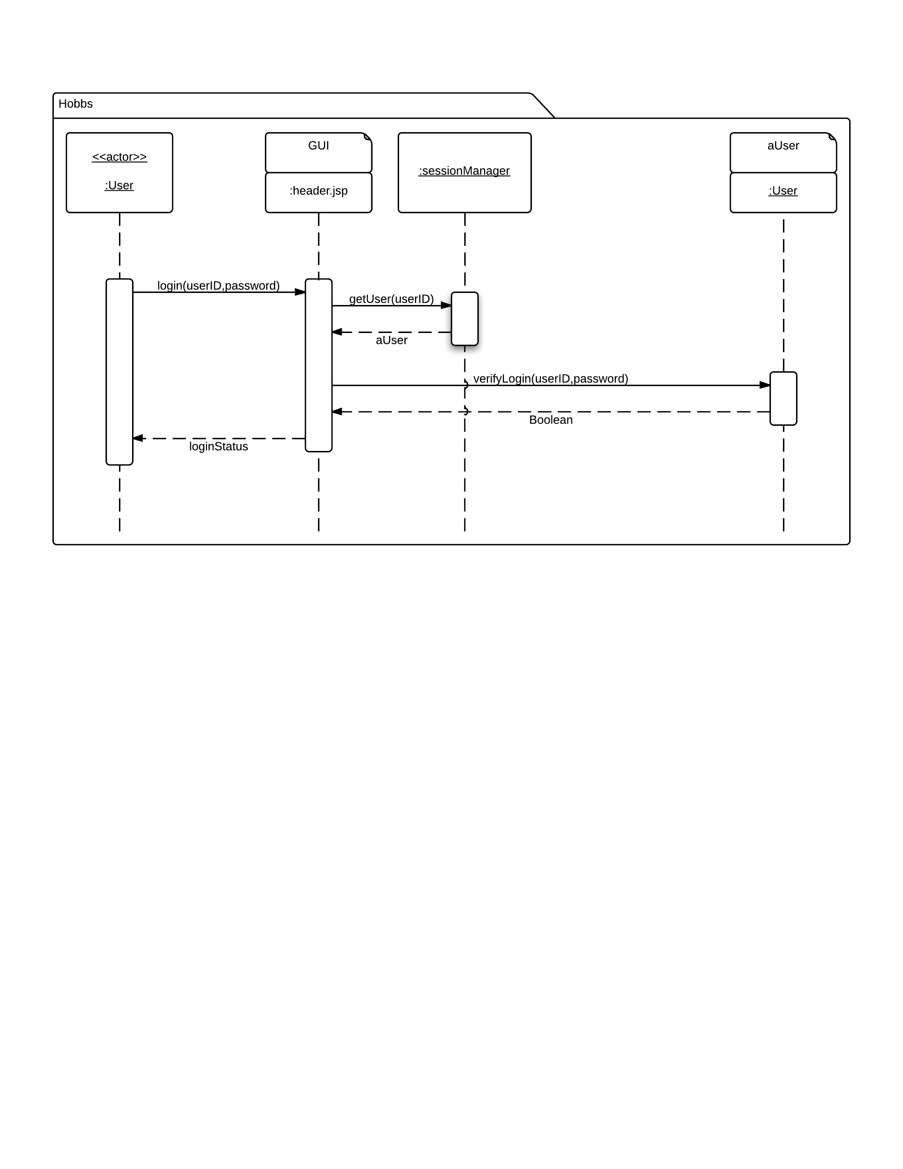
Sequence diagram enables the author and client to see the sequence chain of events and method calls for each action. Figure 5.3.4.1 shows an example modelled by the author of user logging in and the verifications using a sequence diagram. Figure 5.3.4.2 shows the service order and making payment through PayPal using a sequence diagram. Sequence diagram has the interaction between objects in runtime, with the sequence of method invocation; please refer to Appendix [Sequence Diagrams] for these diagrams enlarged as well as the complete collection of all the sequence diagrams used for the developed web-based system. The actors in this diagram are recognised from the requirement and design phase of use-cases created. The sequence diagram is useful for illustrating what happens in the background on a programming level. It specifies exactly what happens in the code, step by step. It includes all the other elements involved in a specific action and links them through method calls. The sequence diagram was shown to the client with clear explanations to ensure the designs were correct and consistent to the system’s requirements. The client was happy with the designs therefore no amendments were required to be made.
Figure 5.3.4.2: Order and Payment Sequence Diagram
Figure 5.3.4.1: Log in Sequence Diagram

Architecture design
The author generated a deployment diagram; this illustrates how the technologies within this project are connected. Figure 5.3.5.1 Deployment diagram clearly shows the client uses a browser to access the Hobbs website on the cloud. The website consists of three elements; JSPs and servlets, Apache Tomcat and MySQL server, JSP and servlets are hosted on the Tomcat server. JSP and servlets are hosted on Tomcat server and access MySQL database for data. PayPal is also another entity which is hosted on the cloud and is connected through JSPs and Servlets.
Figure 5.3.5.1: Deployment Diagram

Entity relationship diagram
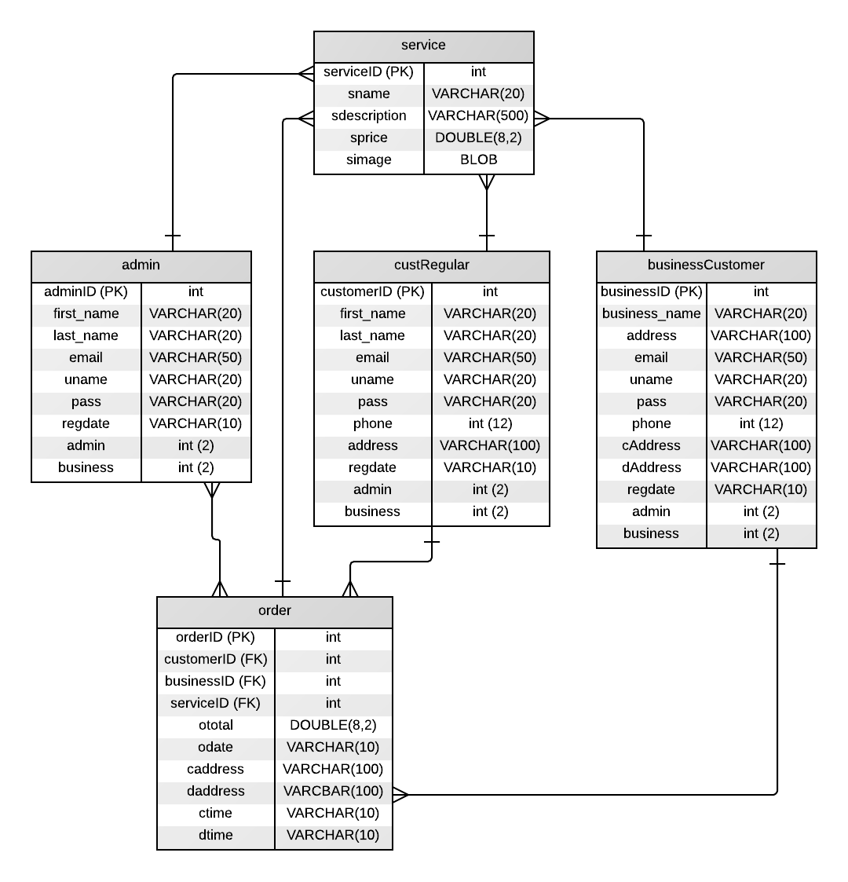
Figure 5.3.6.1: Entity Relationship Diagram

Implementation phase

System development

Working environment

Coding decisions

Source code

Testing phase
Working in an agile way meant that the author regularly tested functionality after each iteration cycle. For each iteration cycle, a series of functional requirements were targeted so the tests were done accordingly.
what were the functional requirements “targeted”? You need to be specific.

This holds throughout the document. The author ran tests after each change by running the system on the Apache Tomcat Server to ensure the change made was intentional and expected, in addition to testing after each iteration, this type of testing took place continuously throughout the project. Testing was done after each iteration cycle to see how the iteration cycle works with the other iterations.
Performance tests were also ran on http://www.webpagetest.org to ensure the web-system would perform as expected on all browsers with minimal resources used.
Manual testing was done
What were the performance test used? What were the outcomes of the test performed? You need to be detailed about this.
The tool could be mentioned in the Literature Review, and/or as part of the Method.

Verification and evaluation
From the tests, it was clear that the web- based system ran smoothly
You have to convince the readers about this – by showing them the results – the raw data, and explaining what had led you to state these claims.
and with minimal strain on all mainstream browsers. After each iteration cycle, the client was made aware of additional implementation and briefed on the progress. Usually in the meeting, the client personally ran the web system on the author’s workstation and experienced the web-based system first hand. The client and a customer within Hobbs business were provided a user evaluation questionnaire from the author so there was chances to receive the final feedback with their opinions to improve the web-based system before handing over the system to the client.
- Staff does not have privileges to add new admin accounts only admin does
- Staff can not also change price information
- Customers could be allowed to add their collection and delivery dtails in the near future.
- I will be maintaining the site even after the project if any changes or problems occur.
- Paypal doesn’t allow order history to be looked at through webpage. The customer has to visit paypal to view all order history and transactions. Also admin can view customers transactions from paypal.
- Admin can edit paypal buttons and description and prices from paypal.
- admin can send messages to customer, they can updated them on their progress, starting, competed etc through messages to the buyer on paypal
- remove staff
- forgot password

Conclusions chapter

Glossary chapter

References chapter

Appendices

Client emails/ Meeting minutes
Output Type: | Emails/ meeting minutes
Overview Description: | This consists of all the requirements set from the client via regular meetings and emails sent within the project. These documents are assigned/ signed to ensure they were asked to be delivered and are met by the author.
Purpose: | The author completes the project requirements according to what is requested through meetings with the client. This ensures the client is satisfied with the system as the author followed all requirements set ensuring any changes that are agreed on with a signature from client and author to avoid any conflicts near the end of the project.
Recipient/ end User: | Author, Supervisor, Client
Reference: | Appendix [Client Emails], Appendix [Meeting Minutes]

